Contents
Abstract 2
Keywords 2
Methods 2
1. Introduction 3
2. Software Engineering 3
2.1. Objectives of Software Engineering 4
2.2. Software development life cycle (SDLC) model 4
2.3. Software Process 6
2.4. Challenges of Software Engineering 6
2.5. Software Development Life Cycle Phases 6
3. Artificial Intelligence 8
3.1. AI Techniques Used in SE 9
References 14

AI in Software Engineering

Name: Tank Awasthi
Tankawasthi1010@gmail.com

Abstract
Artificial Intelligence (AI) and Software Engineering are considered as significant fields to solve various problems. The stages of conceptualization, design and implementation are defined by AI methods. Artificial Intelligence improves a large application domain of software engineering activities. The integration of artificial intelligence with software development life cycle phases for supporting software engineering applications leads to Software Intelligence. The purpose of this case study is to synthesize and analyze the benefits, challenges and risk of applying intelligent techniques to Software Development life cycle phases.

Keywords
Artificial intelligence, software engineering, software development process, artificial intelligence Techniques.

Methods
Using a systematic literature review, review journals, books.

Introduction
Software engineering (SE) consists of two expressions. Software refers to programs that include instructions to supply the required functionality, and engineering refers to the operations of the design and construction to determine the cost of efficient solutions. Thus, the definition of SE is a systematic approach for the design, development, implementation, and maintenance of a software system [1].
As software products become pervasive in all areas of society, the productive building of high-quality software has become crucial to the software industry. The rise of artificial intelligence (AI) applications is potentially a game-changer in improving Software Engineering (SE) phases to ensure higher-quality software, accelerate productivity, and increase project success rates. AI has the capability to assist software teams in many aspects, from automating certain activities in an SE phase to providing project analytics and actionable recommendations, and even making decisions [2].
The primary goal of software engineering is to improve software quality and productivity. For this purpose, many initiatives have emerged, including maturity models, formal methods, reuse-driven software engineering, and value-based software engineering [3].
AI techniques can support software engineers by detecting parts of the SE phases that are more likely to contain vulnerabilities and raising alerts about these issues. They aim to increase the likelihood of finding vulnerabilities and reduce the time required for software engineers to discover these vulnerabilities. SE phases involve various activities that range across all the stages of the Software Development Lifecycle (SDLC) phases. AI techniques like machine learning (ML), heuristic algorithms (HA), deep learning

(DL), data mining (DM), data analytics (DA), and natural language processing (NLP) have been widely explored in the SE phases.
As software grows in size, its complexity increases, along with the time and cost required for its overall construction. Extensive data is generated from all the SDLC stages. This data varies between the planning, requirements engineering, design, system development, testing, deployment, training, and maintenance phases [2].

Software Engineering
SE is the application of engineering to the design, development, and maintenance of software. SE ensures that applications are constructed consistently, correctly, on time, on budget, and within requirements. Figure 2 shows the common keywords in the SE lifecycle. [1]
The success of software engineering projects
largely depends on much complex decision making (e.g., Which tasks should a developer
do first? Who should perform this task? Is a software system of high quality? Is a software system reliable and resilient enough to deploy?). However, the erroneous of these complex decisions is costly in terms of monetary and reputation. Today software development processes depend on a variety of development tools (e.g. issue tracking systems, version control systems, code review, continuous integration, continuous deployment, and Q&A website). [4]

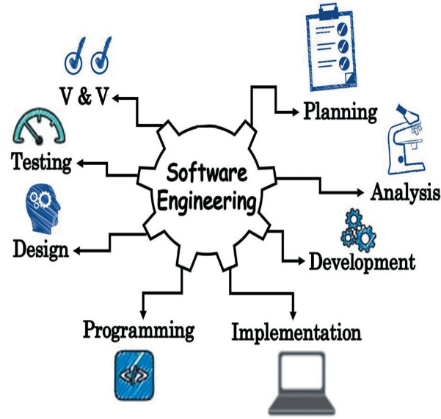
Figure 1. The keywords of the software engineering [1]

2.1. Objectives of Software Engineering
The following points illustrate the main objectives of software engineering.
- Reliability: This attribute of software quality is the extent to which a program can be expected. to perform its desired function over an arbitrary time period.
- Reusability: A software product has good reusability if the different modules of the product can easily be reused to develop new products.
- Maintainability: The software should be feasible to evolve to meet changing requirements.
- Testability: Software establishes test criteria and evaluates software with respect to those criteria.
- Correctness: A software product is correct if the different requirements as specified in the SRS document are correctly implemented.
- Adaptability: Software allows differing system constraints and user needs to be satisfied by making changes to the software.
- Portability: Software can be transferred from one computer system or environment to another. [1]

2.2. Software development life cycle (SDLC) model
SDLC is a conceptual framework or process that considers the structure of the stages involved in the development of an application from its initial feasibility study through to its deployment in the field and maintenance. There are several models that describe various approaches to the SDLC process. An SDLC model is generally used to describe the steps that are followed within the life-cycle framework.
SDLC models for three distinct use cases, or software categories, in order to provide a context for their application, as follows:
Category 1. Software that provides back-end functionality. Typically, this is software that provides a service to other applications.
Category 2. Software that provides a service to an end-user or to an end-user application. Typically, this would be software that encapsulates business logic or formats data to make it more understandable to an end-user.
Category 3. Software that provides a visual interface to an end user. Typically, this is a front-end application that is a graphical user interface (GUI). [5]

Model | Advantages | Disadvantages
Waterfall | - Simple and easy to use and understand  - Easy to manage (i.e., each phase has specific deliverables)  - Processed and completed one at a time.  - Works well for smaller projects. | - High amounts of risk and uncertainty  - Poor for long and ongoing projects  - Cannot accommodate changing requirements  - Difficult to measure progress within stages
Prototyping | - Missing functionality can be identified easily  - Reduce time and cost  - Quicker user feedback is available  - Improved and increased user involvement | - Insufficient analysis  - User confusion  - Developer  - Excessive development
Spiral | - Can changing requirements  - Users see the system early  - Allows extensive use of prototypes  - Helps in better risk management | - Risk of not meeting the schedule or budget  - High cost  - Not useful for small projects.  - Not suitable for low risk projects.
Incremental | - Easy to test and debug  - A customer can respond to each building  - Errors are easy to be identified  - Thought the development stages changes can be done. | - Requires a good planning designing  - Each iteration phase is inflexible and dose not overlap each other  - Problems may arise pertaining to system architecture.  - More expensive comparing to the waterfall model.
Iterative | - Can be developed parallel  - Less costly to change the requirements  - Easy of testing and debugging during smaller iteration  - Easier to manage risk | - Required highly skilled resource for risk analysis  - End of project may not be known  - Management complexity is more  - Not suitable for smaller projects
Agile | - Very realistic approach to software development  - Suitable for fixed or changing requirements  - Need minimal resource requirements  - Easy to manage | - More risk of sustainability  - Very high individual dependency  - Not suitable for handling complex dependencies  - Depends heavily on customer interaction.
Table 1. Software development life cycle models [1]

2.3. Software Process
The software process consists of the activities and associated information that are required to develop a software system. Every organization has its own specific software process but these individual approaches usually follow some more abstract generic process model.
Any software process must include the following
Four activities.
- Specification. The functionality of the software and its operating constraints are specified in detail.
- Design and implementation. The overall structure of the software is designed and specific software components identified. These are implemented using some programming language, often by separate individuals or teams.
- Integration and testing. Individually developed modules are integrated into a complete system and tested.
- Operation and maintenance. The software is delivered to the customer and modified to meet changing requirements and to repair errors discovered in use. [6]

2.4. Challenges of Software Engineering
SE utilizes a well-defined and systematic approach for software development. This approach is considered to be the most effective for producing high-quality software. However, despite this systematic approach in software development, some serious challenges are still faced by SE. Some of these challenges are listed below.
- The methods used to develop small- or medium-scale projects are inapplicable when developing large-scale or complex systems.
- Changes in software development are unavoidable. Currently, changes occur rapidly, and accommodating these changes to complete a software project is a major challenge faced by the software engineers.
- The advancement in computer and software technology has necessitated for the changes in the nature of software systems. Software systems that cannot accommodate changes are not considerably useful. Thus, a challenge in SE is to produce high-quality software that adapts to the changing needs within acceptable schedules. To meet this challenge, the object oriented approach is preferred; however, accommodating changes to software and its maintenance within acceptable cost remains a challenge.
- Informal communications account a considerable portion of the time spent on software projects. Such wastage of time delays the completion of projects in the specified time.
- The user generally has only a vague idea about the scope and requirements of the software system. This usually results in the development of software, which does not meet the user’s requirements.
- Changes are usually incorporated in documents without following any standard procedure. Thus, verification of such changes often becomes difficult.
- The development of high-quality and reliable software requires the software to be thoroughly tested. Although thorough testing of software consumes the majority of resources, underestimating it deteriorates the software quality. [1]

2.5. Software Development Life Cycle Phases
These SE phases included features and observations from existing studies and consisted of eight phases: (i) planning, (ii) requirements engineering, (iii) design, (iv)system development, (v) testing, (vi) deployment, (vii) training, and (viii) maintenance.
1) PLANNING
The planning phase is when the project plan is developed and involves identifying, prioritizing, and assigning the tasks and resources required to build the structure for a project.
2) REQUIREMENTS ENGINEERING
This is the second phase, in which each set of relevant information is elicited, analyzed, prioritized, and negotiated. The next phase of RE involves a detailed definition of the requirements, documenting these requirements, and getting verification from the stakeholders.
3) DESIGN
This is the third phase and is concerned with the whole structure of the future project to be implemented. The software requirement specification is used as the input to design
the architecture, database and user interface of the software product being developed.
4) SYSTEM DEVELOPMENT
The fourth step consists of the coding that builds the software. It incorporates all elements such as classes, files, infrastructure, and executable task. In this phase, the actual
Development of the product starts according to the designed architecture.
5) TESTING
The testing involves the veri_cation and correction of any
defective parts of the code. All are thoroughly tested and
retested if necessary until all the problems are resolved.
6) DEPLOYMENT
In the deployment phase, the software/subsystem/components are placed and executed on the required physical hardware nodes (e.g., mobile, server, or desktop). The project is then made available to the end-users.
7) TRAINING
The training activities perform a detailed audience and task analysis through interaction with the proposed users of the
system, the key client representatives, whereby the training increases knowledge and usability.
8) MAINTENANCE
The maintenance phase follows the entire life cycle of the software. If users or developers find a problem, it may be fixed or corrected ahead of the next release, depending on how serious it is. [2]

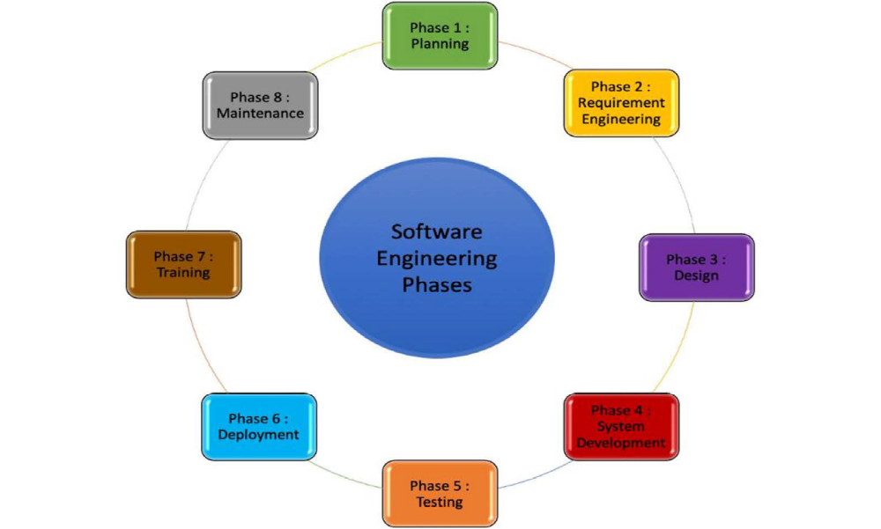
Figure 2. Software engineering phases. [1]

AI TECHNIQUES HAVE BEEN
USED IN SE?

Artificial Intelligence
Winston and Prendergast mentioned that Artificial Intelligence is “the study of the computations that make it possible to perceive, reason, and act”. According to Kurzweil et al. AI is “the art of creating machines that perform functions that require intelligence when performed by people”.
AI applications are used to simulate human intelligence for providing help in problem solving and decision making. Figure 1 shows an overview of the fields, methods, and techniques of AI. AI has numerous advantages, such as making decisions with rapid thinking, replacing humans in certain jobs such as dangerous tasks, and simplifying life such as with the use of smartphones and GPS. However, AI also has flaws, such as being expensive, and it may cause adverse results such as corruption or malfunction in robot armies and possibility of mass destruction and create unemployment in certain sectors. [1]
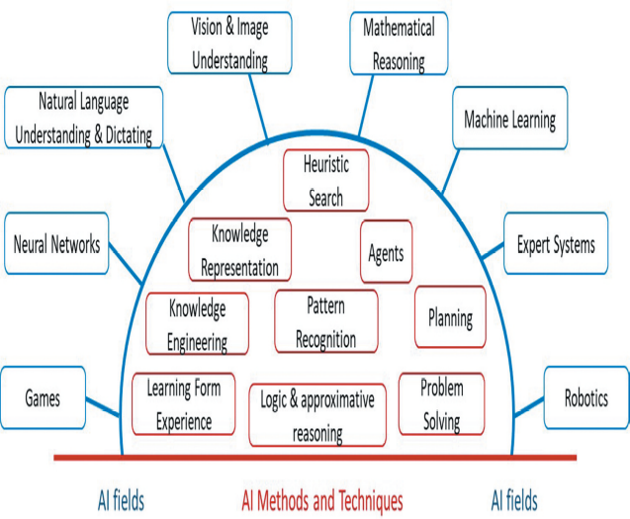
Figure 3. AI fields, methods, and techniques [1]

AI Techniques Used in SE
Along with the flourishing of AI techniques in modern computing, many researchers and studies are investing AI in their domain. Referring to Table 4, eight AI techniques have been used extensively to facilitate activities in SE: Machine Learning (ML), Heuristic Algorithm (HA), Deep Learning (DL), Data Driven (DD), Machine Learning (ML), C Natural Language Processing (NLP), Machine Learning (ML) C Data Driven (DD), Machine Learning (ML) C Heuristic Algorithm (HA), and Deep Learning (DL) C Data-Driven (DD). Each AI technique has its own AI capabilities. The current analysis reveals that ML in SE has recently received increased attention. There has been a growing interest in applying ML to automate various SE phases. These findings show that ML has been applied to address a myriad of SE problems and it has attracted greater interest among researchers and practitioners than other AI techniques. The current results suggest that interest in applying
ML in the SE phases has risen considerably in recent years. Data-driven techniques were reported as the emerging AI techniques in SE. Data-driven techniques can identify and evaluate which decision-modeling techniques would help
in making important decisions. Data-driven techniques usually explore the potential of predictive analytics offered by AI techniques, which enables AI-based decision making. The heuristic algorithm is another important AI technique that has been used in SE. This is designed to solve a problem faster and more efficiently than the traditional methods by sacrificing optimality, accuracy, precision, or completeness for speed. Heuristic algorithms (HA) are used to solve SE problems, a class of decision problems. A HA can produce a solution individually or be used to provide a good baseline and then supplemented with optimization algorithms. [2]
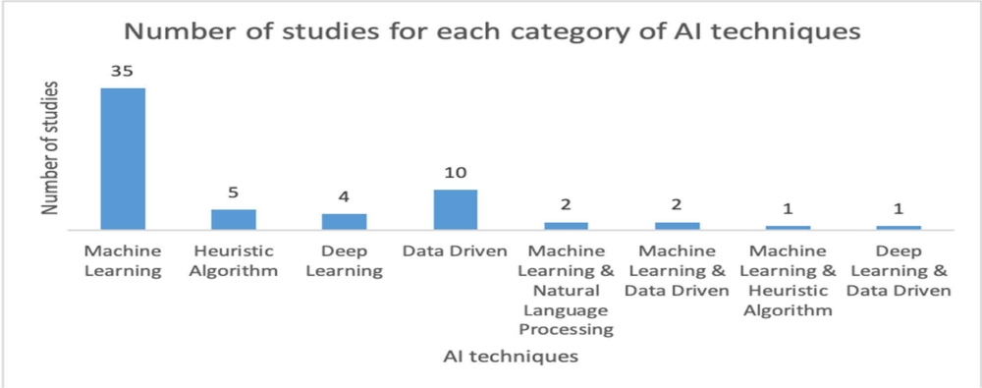
Figure 4. Number of studies for each category of AI techniques. [2]

References

[1] | M. Shehab, L. Abualigah, M. Jarrah, O. Alomari and M. Daoud, "Systematic Mapping: Artificial Intelligence," International Journal of Computer Integrated Manufacturing, vol. 33, no. 2, pp. 10-11, 2020.
[2] | H. Sofian, N. Yunus and R. Ahmad , "Systematic mapping: Artificial intelligence techniques in software engineering," IEEE Access, vol. 10, no. 2, pp. 51021-51040, 2022.
[3] | M. Perkusich, A. Costa, L. C. e. Silva, A. Costa, F. Ramos, R. Saraiva, A. Freire, Dantas, E. Dantas, D. Santos, K. Gorgonio, H. Almeida and A. Perkusich, "Intelligent Software Engineering in the Context of Agile Software," Information and Software Technology, vol. 119, no. 3, p. 106241, 2019.
[4] | Tantithamthavorn, C. Kla and J. Jiarpakdee, "Explainable ai for software engineering," in IEEE/ACM International Conference on Automated Software Engineering (ASE), 2021.
[5] | R. and N. B, "Software development lifecycle models," in ACM SIGSOFT Software Engineering Notes 35, 2010.
[6] | S. Ian, "Software process models.," ACM computing surveys (CSUR), vol. 28.1, no. 6, pp. 269-271, 1996.

